FPGA Based Matrix Multiply Accelerator

Chapter 1: Introduction:
These days, Artificial Intelligence and Machine Learning are everywhere. From the face unlock on your phone to medical image diagnosis, AI is being used in almost every field. But if you look under the hood of any AI system, especially neural networks, almost all the heavy computation comes down to one operation that is matrix multiplication. When a neural network processes data, it is basically multiplying huge matrices again and again, billions of times during training and millions of times during inference. The problem faced is that doing this on a normal computer processor (CPU) is very slow. CPUs are designed to do one or two things at a time, not thousands of multiplications in parallel. Even GPUs, which are much better at parallel tasks, consume a lot of power and are expensive. So researchers and engineers have been looking for smarter ways to accelerate matrix multiplication using dedicated hardware.
1.2 Role of FPGAs in Hardware Acceleration
This is where FPGAs come in. A Field-Programmable Gate Array is a chip that can be programmed to behave like any digital circuit you want. Unlike a CPU where the hardware is fixed, in an FPGA you are literally designing the hardware itself. You can create as many adders, multipliers, and registers as the chip can fit, and make them all work simultaneously. For matrix multiplication, this is a huge advantage. Instead of computing one multiplication at a time, an FPGA can run tens or hundreds of multiplier units in parallel, each handling a different part of the matrix at the same time. In our DDHDL course, we have been learning to design such circuits using Verilog HDL, and this project gave us a practical opportunity to apply those concepts to a real-world AI problem.
1.3 Problem Statement
Matrix multiplication has a time complexity meaning as the matrix size doubles, computation time increases by eight times. This is not practical for real-time AI applications. Existing hardware solutions either use too many resources, consume too much power, or do not scale well. Our project aims to design an FPGA-based parallel matrix multiplication accelerator that is efficient in both speed and resource usage, starting from the basic arithmetic building blocks and working up to a complete system.
1.4 Objectives of the Project
- To study how matrix multiplication can be implemented efficiently on an FPGA.
- To design three core leaf cell components in Verilog HDL: an 18-bit adder, an 8×8 multiplier, and a D flip-flop.
- To write test benches and verify each component through simulation waveforms and RTL diagrams.
- To review existing research papers on FPGA-based matrix accelerators and compare their approaches.
- To identify gaps in current designs and explain how our approach addresses them.
1.5 Scope of the Report
This report is the secondary research document for our PBL project. It covers a literature review of four relevant research papers, a comparative analysis table, identification of research gaps, our proposed system design with block and architecture diagram descriptions, and detailed descriptions of our three leaf cell designs with simulation results. Verilog code, RTL diagrams, and waveform screenshots are included in the appendix.
Chapter 2: Literature Review (Secondary Research)

2.2 Comparative Analysis Table:
Paper 1: FPGA Based Matrix Multiplication Accelerator
- Architecture Used: Pipeline based parallel architecture
- Throughput: High throughput due to continuous pipelined execution
- Resource Utilization: Uses LUTs, flip flops, and DSP blocks
Limitations: Increased hardware usage for higher parallelism

Paper 2: Design and Performance Analysis of MAC Unit
- Architecture Used: MAC unit with different multiplier architectures
- Throughput: Moderate to high based on multiplier design
- Resource Utilization: Requires DSP slices, LUTs, and registers
- Limitations: Delay increases due to sequential accumulation

Paper 3: Systolic Array Matrix Multiplication Accelerator
- Architecture Used: Systolic array based parallel architecture
- Throughput: Very high throughput due to simultaneous processing elements
- Resource Utilization: High usage of DSP blocks and registers
- Limitations: Complex design and high area consumption

Paper 4: FPGA Accelerated Systems using Parallel Patterns
- Architecture Used: Parallel pattern based architecture with pipelining
- Throughput: Improved throughput using loop unrolling and parallel execution
- Resource Utilization: Increased LUT and DSP usage due to optimizations
- Limitations: Performance depends on optimization techniques and workload complexity

Paper | Architecture | Throughput | Area | Limitations
Paper 1: SaiKumar et al. (2014) | MAC unit with Array, Booth, Wallace Tree and DADDA Multipliers + Carry Save Adder on Virtex-6 FPGA | Low — best delay 3.6592 ns but only single MAC unit, not full matrix system | 92 to 137 LUTs; Power: 1.01 W to 2.14 W | Only single MAC unit tested; no full matrix multiplication implemented
Paper 2: Deb et al. (2025) | 6-stage Pipeline using FCSD multiplication; fully LUT-based, no DSP blocks; Zynq-7000 and Artix-7 | High — peak 11.11 GOP/s on Artix-7 for 71×71 matrix | 5042 LUTs for 4×4 matrix; no DSPs used; Zynq-7000 maxes out at 34×34 | LUT usage grows too fast; not scalable for large matrices on resource-limited FPGAs
Paper 3: Puscasu et al. (2024) | 2D Systolic Array with MAC-based Processing Elements; multi clock-domain; SystemVerilog on VCU128 | High — up to 145.5× speedup over RISC-V processor for 64×64 array | 9.71% LUTs, 45.39% DSPs for 64×64 array; DSP usage grows quadratically | DSP usage becomes too high for larger arrays; 128×128 not feasible on target board
Paper 4: Birath et al. (2024) | SkePU skeleton framework with loop unrolling and shift registers; tested on Intel Arria 10 GX FPGA | Medium — close to GPU for simple tasks but slow for matrix multiplication | Resource usage varies with unroll factor; higher unroll uses more DSPs and LUTs | Auto-generated code much slower than hand-written HDL; nested loops break pipelining

2.3 Research Gap Identification:
1. Component-level validation is missing
Most designs do not verify individual components before system integration, making debugging and fault isolation difficult.
2. Poor balance between speed and area
Most designs optimize either speed or area, but not both; a balanced architecture is required for efficient FPGA utilization.
3. Overflow not addressed in accumulation
Existing designs do not consider bit-width growth during repeated additions, leading to potential overflow and inaccurate results.
4. Lack of optimized HDL design methodology
Although manual HDL coding improves performance, existing works do not provide clear guidelines for designing efficient hardware modules.
Why Improvement is Needed:
Looking at all four papers together, we feel that most existing designs are focused on showing impressive numbers like high throughput or low delay, but they skip the basics. Nobody shows how to properly design and test the small components that everything else is built on. Nobody talks about overflow during accumulation. And nobody finds that sweet spot between using too many LUTs and using too many DSPs. Our project tries to fix at least some of these things by starting from the leaf cells, testing each one properly, using an 18-bit adder to handle larger sums, and keeping the overall design simple and easy to understand.

Chapter 3: Proposed System Design

Design Justification
- The proposed system uses an FPGA-based parallel MAC (Multiply-Accumulate) architecture for matrix multiplication.
- Matrix multiplication requires repeated multiply and add operations.
- MAC units efficiently combine both operations .
- FPGA enables parallel execution of multiple MAC units
- A 3×3 Parallel MAC Array (9 units) is used .
- All MAC units compute simultaneously in one clock cycle
- Improvement over literature:
- Reduces computation time compared to sequential designs.
- Achieves high throughput using parallelism
- Efficient use of FPGA DSP blocks

3.2 Block Diagram:
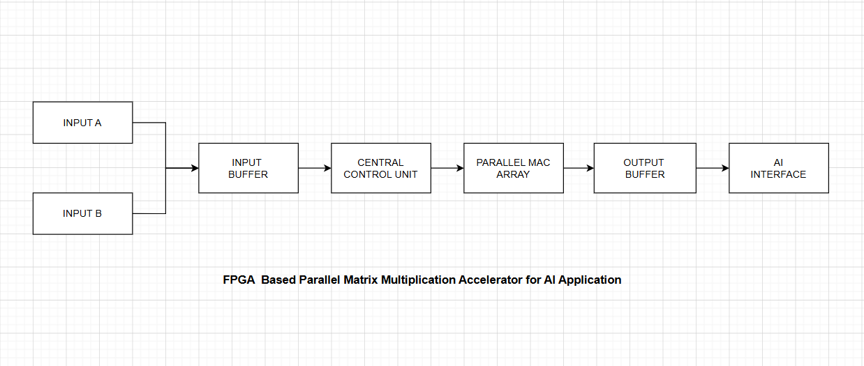

3.3 Architecture Diagram:
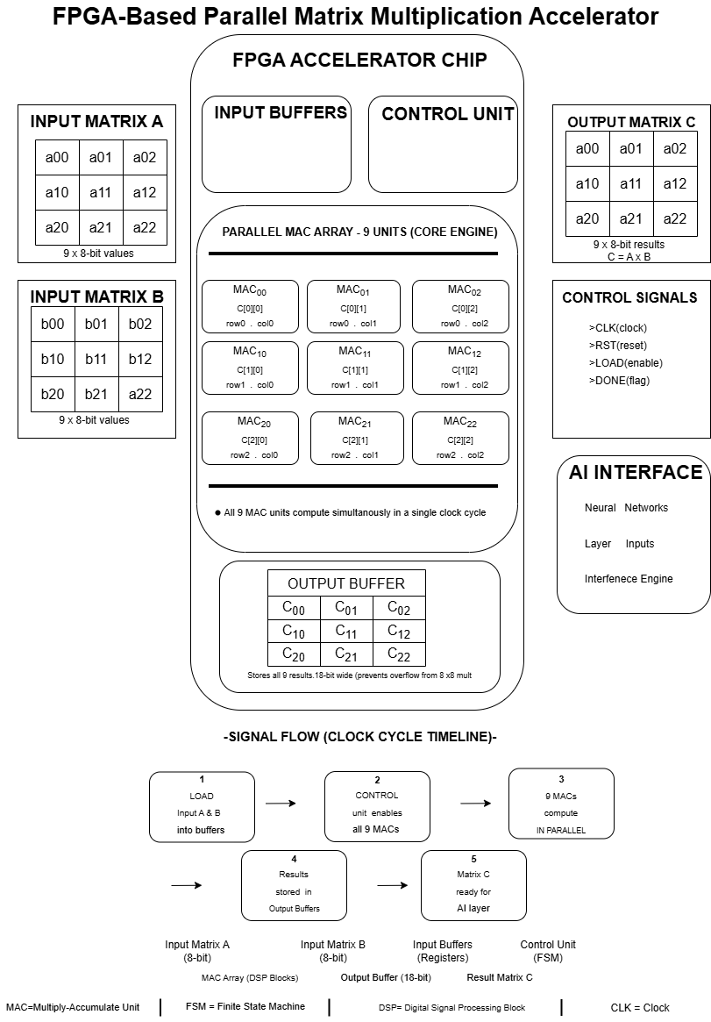
The architecture represents an FPGA based parallel matrix multiplication accelerator designed for AI applications. It performs multiplication of two input matrices A and B using a parallel processing approach.
Input Matrices:
Matrix A and Matrix B are given as inputs. Each matrix consists of 3×3 elements with 8 bit values. These inputs are fed into the FPGA accelerator for processing.
Input Buffers:
The input buffers store the matrix elements temporarily. They ensure continuous and organized data supply to the computation units. This helps in reducing delay and supports smooth data flow.
Control Unit:
The control unit acts as the main controller of the system. It is implemented using a finite state machine. It generates control signals such as clock reset load and done. It manages the sequence of operations and enables the MAC units during computation.
Parallel MAC Array:
The core of the architecture is the parallel MAC array consisting of 9 MAC units arranged in a 3×3 structure. Each MAC unit performs multiplication and accumulation operations. All MAC units operate simultaneously, allowing parallel computation of matrix elements. This significantly reduces computation time.
Output Buffer:
The output buffer stores the resulting matrix C. Each value is stored in higher bit width to prevent overflow due to multiplication and accumulation. It ensures stable and correct output data.

Chapter 4: Leaf Cell Design:
4.1 Identification of Leaf Cells
The smallest reusable units used in this design are:
- Multiplier (8×8 Multiplier)
- Adder (18 bit Adder)
- Register (D Flip Flop)
- Multiplier (8x8 Multiplier)
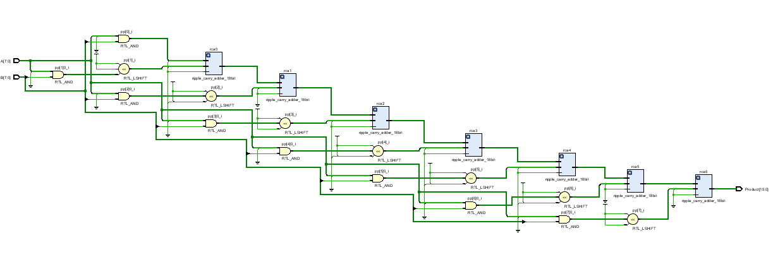
- Multiplying elements of matrix A and matrix B.
- Generates partial products in matrix multiplication
Formula :
P=A × B
2. Adder (18 bit Adder):
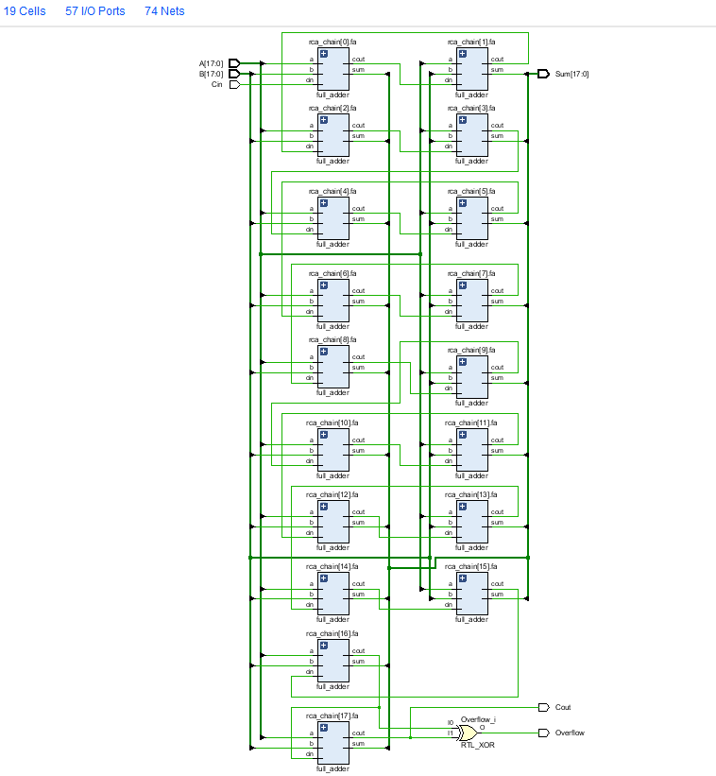
- Adding partial products from multipliers
- Performing accumulation in MAC operation
Formula:
S=A+ B
3. D Flip Flop:
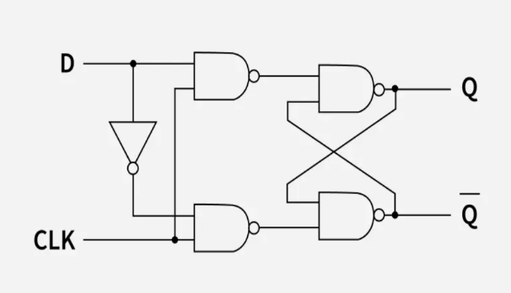
- Storing intermediate and final values
- Synchronizing data with clock signal
Formula:
Q(t+1) = D
4.3 Leaf Cell Simulation:
D- flipflop:
Design:
Design :
module d_ff (
input wire clk,
input wire D,
output reg Q,
output wire Q_bar
);
always @(posedge clk) begin
Q <= D;
end
assign Q_bar = ~Q;
endmodule
// ------ D Flip-Flop with Synchronous Reset (Active High) ------
module d_ff_sync_reset (
input wire clk,
input wire rst,
input wire D,
output reg Q,
output wire Q_bar
);
always @(posedge clk) begin
if (rst)
Q <= 1'b0;
else
Q <= D;
end
assign Q_bar = ~Q;
endmodule
// ------ D Flip-Flop with Asynchronous Reset (Active High) ------
module d_ff_async_reset (
input wire clk,
input wire rst,
input wire D,
output reg Q,
output wire Q_bar
);
always @(posedge clk or posedge rst) begin
if (rst)
Q <= 1'b0;
else
Q <= D;
end
assign Q_bar = ~Q;
endmodule
// ------ N-bit D Register ------
module d_register #(
parameter WIDTH = 18
)(
input wire clk,
input wire rst,
input wire en,
input wire [WIDTH-1:0] D,
output reg [WIDTH-1:0] Q
);
always @(posedge clk or posedge rst) begin
if (rst)
Q <= {WIDTH{1'b0}};
else if (en)
Q <= D;
end
endmodule
Testbench:
module tb_d_ff;
reg clk, rst, D;
wire Q_basic, Q_bar_basic;
wire Q_sync, Q_bar_sync;
wire Q_async, Q_bar_async;
// Instantiate all three variants
d_ff uut0 (.clk(clk), .D(D), .Q(Q_basic), .Q_bar(Q_bar_basic));
d_ff_sync_reset uut1 (.clk(clk), .rst(rst), .D(D), .Q(Q_sync), .Q_bar(Q_bar_sync));
d_ff_async_reset uut2 (.clk(clk), .rst(rst), .D(D), .Q(Q_async), .Q_bar(Q_bar_async));
// Clock: 10ns period = 100 MHz
initial clk = 0;
always #5 clk = ~clk;
initial begin
// â"€â"€ Initialise â"€â"€
rst = 1;
D = 0;
#12; // hold reset for 12ns (past first posedge)
// â"€â"€ Release reset, apply D=1 â"€â"€
rst = 0;
@(posedge clk); #1;
D = 1;
@(posedge clk); #1;
$display("T=%0t ns | D=1 captured | Q_basic=%b Q_sync=%b Q_async=%b",
$time, Q_basic, Q_sync, Q_async);
// Expected: all = 1
// â"€â"€ Apply D=0 â"€â"€
@(posedge clk); #1;
D = 0;
@(posedge clk); #1;
$display("T=%0t ns | D=0 captured | Q_basic=%b Q_sync=%b Q_async=%b",
$time, Q_basic, Q_sync, Q_async);
// Expected: all = 0
// â"€â"€ Test async reset mid-cycle â"€â"€
D = 1;
@(posedge clk); #1; // D=1 captured, all Q = 1
rst = 1;
#2; // 2ns after posedge, still mid-cycle
$display("T=%0t ns | Async rst=1 mid-cycle | Q_async=%b (expect 0) Q_sync=%b (expect 1, waits for clk)",
$time, Q_async, Q_sync);
@(posedge clk); #1; // NOW sync reset takes effect
$display("T=%0t ns | After posedge with rst=1 | Q_sync=%b (expect 0) Q_async=%b (expect 0)",
$time, Q_sync, Q_async);
// â"€â"€ Release reset, confirm recovery â"€â"€
rst = 0;
@(posedge clk); #1;
D = 1;
@(posedge clk); #1;
$display("T=%0t ns | After rst release D=1 | Q_sync=%b Q_async=%b (both expect 1)",
$time, Q_sync, Q_async);
// â"€â"€ Q_bar check â"€â"€
$display("T=%0t ns | Q_bar_basic=%b Q_bar_sync=%b Q_bar_async=%b (all expect 0)",
$time, Q_bar_basic, Q_bar_sync, Q_bar_async);
$display("-- Simulation complete --");
$finish;
end
endmodule
Waveform:
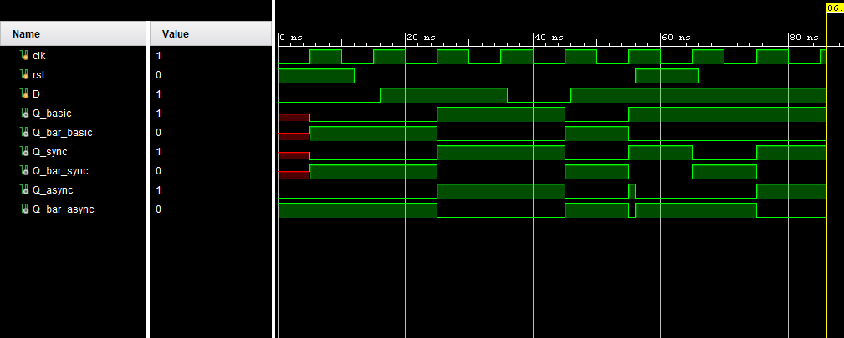
RTL design :
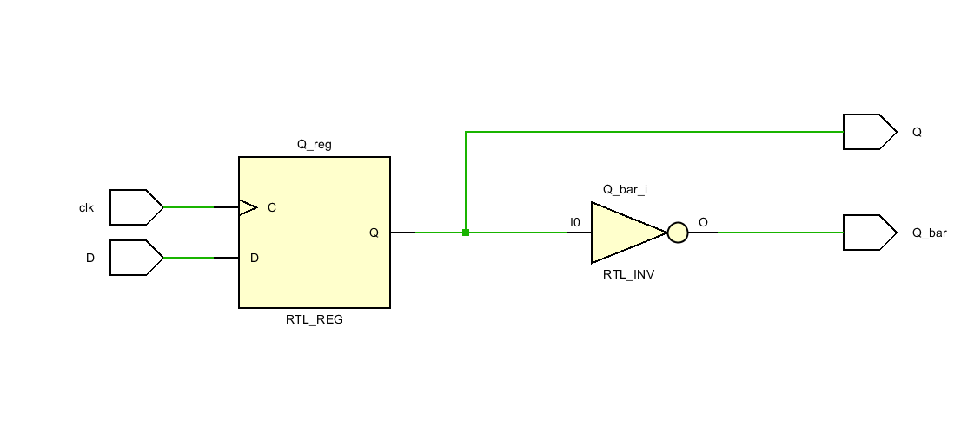

2)8x8 multiplier:
module multiplier_8x8 (
input wire [7:0] A, // 8-bit Multiplicand
input wire [7:0] B, // 8-bit Multiplier
output wire [15:0] Product // 16-bit Product
);
// --- Partial Products (8 rows x 8 bits) ---
wire [15:0] pp [0:7];
genvar i;
generate
for (i = 0; i < 8; i = i + 1) begin : partial_products
// Each partial product is A AND-ed with bit i of B, shifted left by i
assign pp[i] = ({{8{1'b0}}, A} & {16{B[i]}}) << i;
end
endgenerate
// --- Summing partial products using ripple carry adders ---
// Fixed: Wires must be 18-bits to match the RCA output port
wire [17:0] sum0, sum1, sum2, sum3, sum4, sum5;
wire c0, c1, c2, c3, c4, c5;
// Stage 1
ripple_carry_adder_18bit rca0 (.A({2'b0, pp[0]}), .B({2'b0, pp[1]}), .Cin(1'b0),
.Sum(sum0), .Cout(c0), .Overflow());
// Stage 2
ripple_carry_adder_18bit rca1 (.A(sum0), .B({2'b0, pp[2]}), .Cin(1'b0),
.Sum(sum1), .Cout(c1), .Overflow());
// Stage 3
ripple_carry_adder_18bit rca2 (.A(sum1), .B({2'b0, pp[3]}), .Cin(1'b0),
.Sum(sum2), .Cout(c2), .Overflow());
// Stage 4
ripple_carry_adder_18bit rca3 (.A(sum2), .B({2'b0, pp[4]}), .Cin(1'b0),
.Sum(sum3), .Cout(c3), .Overflow());
// Stage 5
ripple_carry_adder_18bit rca4 (.A(sum3), .B({2'b0, pp[5]}), .Cin(1'b0),
.Sum(sum4), .Cout(c4), .Overflow());
// Stage 6
ripple_carry_adder_18bit rca5 (.A(sum4), .B({2'b0, pp[6]}), .Cin(1'b0),
.Sum(sum5), .Cout(c5), .Overflow());
// Final stage
wire [17:0] final_sum;
ripple_carry_adder_18bit rca6 (.A(sum5), .B({2'b0, pp[7]}), .Cin(1'b0),
.Sum(final_sum), .Cout(), .Overflow());
assign Product = final_sum[15:0];
endmodule
// --- ADDED: Missing Ripple Carry Adder Module ---
module ripple_carry_adder_18bit (
input wire [17:0] A,
input wire [17:0] B,
input wire Cin,
output wire [17:0] Sum,
output wire Cout,
output wire Overflow
);
// Simple behavioral description of the RCA for 18-bits
assign {Cout, Sum} = A + B + Cin;
assign Overflow = (A[17] == B[17]) && (Sum[17] != A[17]);
endmodule
Testbench :
module tb_multiplier_8x8;
reg [7:0] A, B;
wire [15:0] Product;
reg [15:0] Expected;
multiplier_8x8 uut (.A(A), .B(B), .Product(Product));
task check;
input [7:0] a_in, b_in;
begin
A = a_in; B = b_in;
Expected = a_in * b_in;
#10;
if (Product === Expected)
$display("PASS: %0d x %0d = %0d", A, B, Product);
else
$display("FAIL: %0d x %0d = %0d (expected %0d)", A, B, Product, Expected);
end
endtask
initial begin
check(8'd0, 8'd0);
check(8'd1, 8'd1);
check(8'd5, 8'd3);
check(8'd15, 8'd15);
check(8'd255, 8'd255);
check(8'd128, 8'd2);
check(8'd200, 8'd100);
check(8'd7, 8'd11);
$finish;
end
endmodule
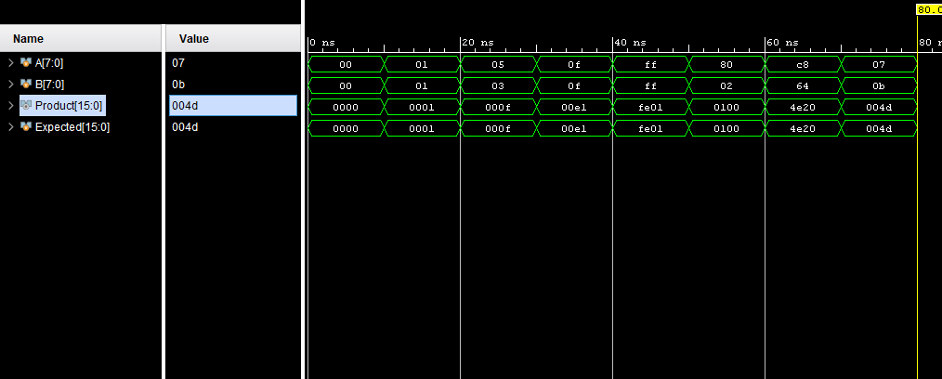
3)8-bit ripple carru adder :
module full_adder (
input wire a,
input wire b,
input wire cin,
output wire sum,
output wire cout
);
assign sum = a ^ b ^ cin;
assign cout = (a & b) | (b & cin) | (a & cin);
endmodule
// ============================================================
// 18-bit Ripple Carry Adder
// ============================================================
module ripple_carry_adder_18bit (
input wire [17:0] A,
input wire [17:0] B,
input wire Cin,
output wire [17:0] Sum,
output wire Cout,
output wire Overflow
);
wire [18:0] carry;
assign carry[0] = Cin;
genvar i;
generate
for (i = 0; i < 18; i = i + 1) begin : rca_chain
full_adder fa (
.a (A[i]),
.b (B[i]),
.cin (carry[i]),
.sum (Sum[i]),
.cout(carry[i+1])
);
end
endgenerate
assign Cout = carry[18];
assign Overflow = carry[17] ^ carry[18];
endmodule
TESTBENCH
module tb_ripple_carry_adder_18bit;
reg [17:0] A, B;
reg Cin;
wire [17:0] Sum;
wire Cout, Overflow;
ripple_carry_adder_18bit uut (
.A(A), .B(B), .Cin(Cin),
.Sum(Sum), .Cout(Cout), .Overflow(Overflow)
);
// Prints every time any signal changes - visible in Tcl Console
initial
$monitor("T=%0t ns | A=%0d B=%0d Cin=%b | Sum=%0d Cout=%b Overflow=%b",
$time, A, B, Cin, Sum, Cout, Overflow);
initial begin
A = 0; B = 0; Cin = 0;
#5;
// Test 1: simple addition
A = 18'd100; B = 18'd200; Cin = 1'b0;
#20;
$display("Test1: %0d + %0d = %0d | Cout=%b Overflow=%b", A, B, Sum, Cout, Overflow);
// Test 2: max value + carry-in
A = 18'h1FFFF; B = 18'h1FFFF; Cin = 1'b1;
#20;
$display("Test2: 0x%h + 0x%h + 1 = 0x%h | Cout=%b Overflow=%b", A, B, Sum, Cout, Overflow);
// Test 3: zero
A = 18'd0; B = 18'd0; Cin = 1'b0;
#20;
$display("Test3: 0 + 0 = %0d | Cout=%b Overflow=%b", Sum, Cout, Overflow);
// Test 4: powers of two
A = 18'd1024; B = 18'd2048; Cin = 1'b0;
#20;
$display("Test4: %0d + %0d = %0d | Cout=%b Overflow=%b", A, B, Sum, Cout, Overflow);
// Test 5: carry-in effect
A = 18'd500; B = 18'd499; Cin = 1'b1;
#20;
$display("Test5: %0d + %0d + 1 = %0d | Cout=%b Overflow=%b", A, B, Sum, Cout, Overflow);
$display("--- Simulation complete ---");
$finish;
end
endmodule


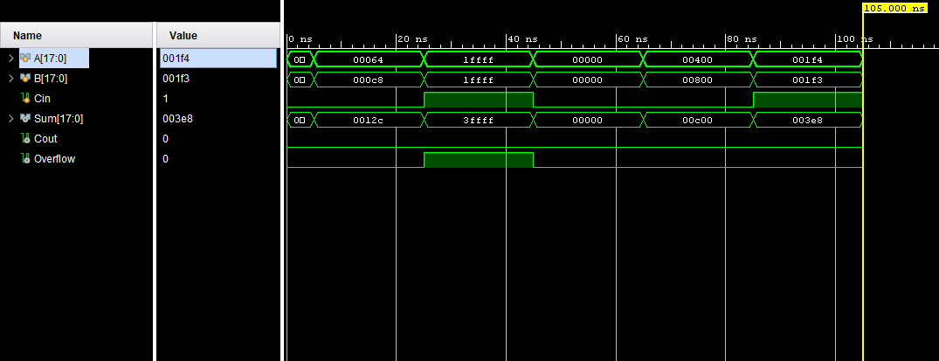

Appendix:
Tools used:
1)vivado hdl
2) diagrams.net (draw.io)
Reference:
The design and implementation of the proposed FPGA based matrix multiplication accelerator are based on insights from various research works in the field of parallel computing, hardware acceleration, and digital system design. The concepts of multiply accumulate units, parallel processing architectures, and FPGA optimization techniques were referred to in order to improve performance and efficiency. Additional understanding was gained from studies on loop unrolling, pipelining, and hardware level parallelism, which are widely used in high speed computation systems. These references collectively contributed to the development of an efficient and scalable architecture suitable for AI applications.

